Capstone Project (Crimes in India)

# Phase 1: Data Collection/Preparation

1. [Population of India (from years 2001-2012)](https://docs.google.com/spreadsheets/d/1R_1jgEN4vitagHNCbHV3v4aQlmjP16XZmK4oG8l9HOs/edit?usp=sharing): I have taken the data of population for the [year 2001](https://www.wbhealth.gov.in/other_files/2007/14_5.html) and I have extrapolated the same till the year 2012 with the growth factor of 1.5%.
2. [Literacy Rate in each state (from the years 2001-2012)](https://docs.google.com/spreadsheets/d/1Xhk2RkYF5ZeGJSHkAwxabccslp206s34zJdkszROZJI/edit?usp=sharing): I have taken the data of literacy for the [year 2001](https://socialjustice.gov.in/common/76669) and I have extrapolated the same till the year 2012 with the growth factor of 2%.
3. [Area of each state](https://en.wikipedia.org/wiki/List_of_states_and_union_territories_of_India_by_area):

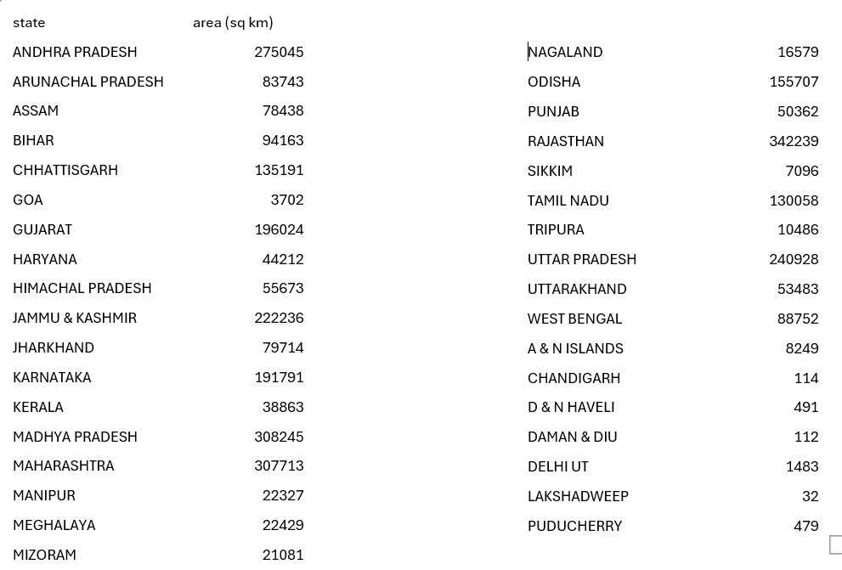

# Phase 2: State/UT wise analysis

2.1 Analysis of Literacy Rate vs Total Crimes.

We have made a table in excel having columns state, year, total crimes, literacy, area, crime density. Crime density was calculated using the formula: total crimes/area

The graphs were:

The filters were calculated, and the second graph was drawn for each year. A bar chart was drawn between the crime rate and state for each year. For the year 2001, we can see that the union territories Delhi UT, and Chandigarh have the highest crime density.

2.2 Analysis of the type of crime vs each state vs Literacy rate.

We have drawn a pivot table having the state and the sum of each type of crime for each year. We have drawn a bar chart for each state and the sum of all the types of crime.

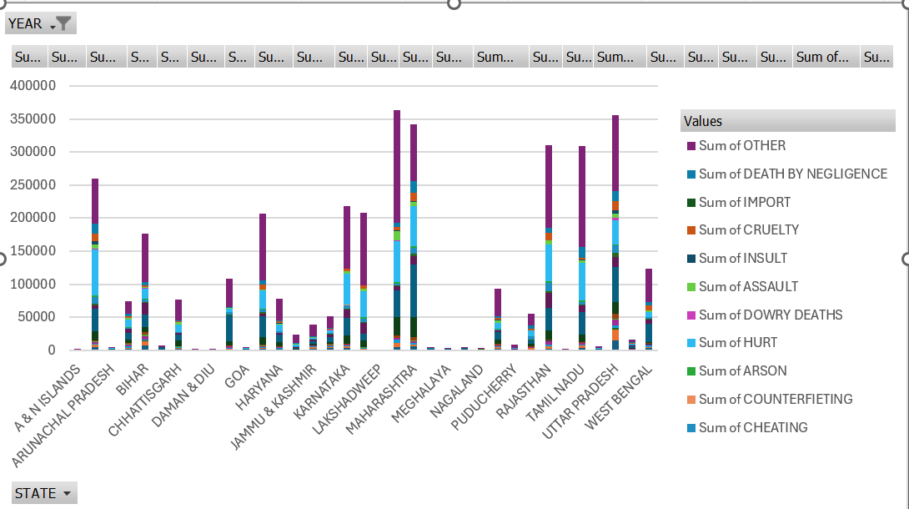

2. 3 Analysis of year-on-year total crime rate

The year-on-year total crime rate was calculated using the following formula: ((Total crime (for year x) – Total crime (for year x-1) / Total crime (for year x-1))/100

The graph we got was as follows:

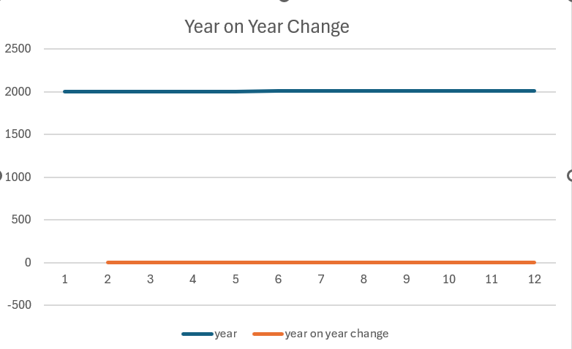

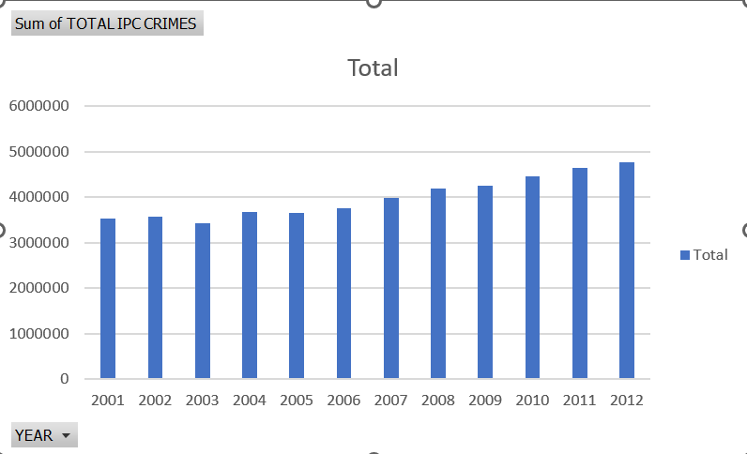

2.4 Analysis of area vs overall crime.

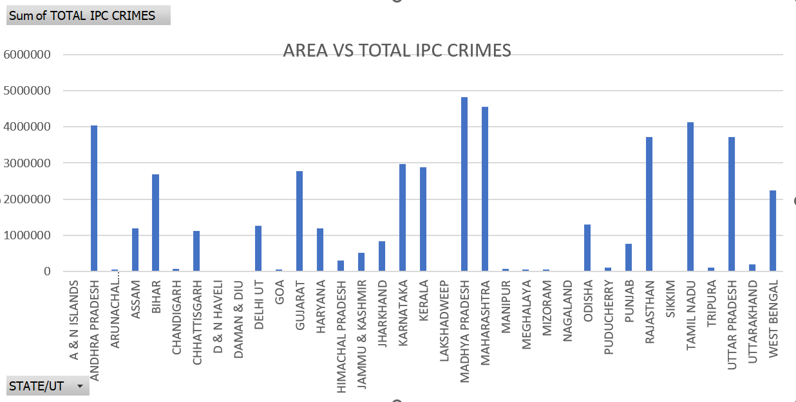

2. 5 Analysis of Population vs overall crime

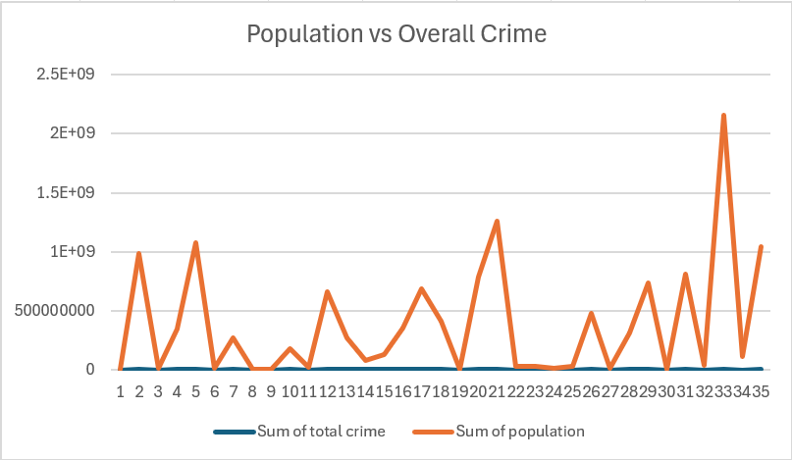

2.6 Crime report for a state

Andhra Pradesh (2001)

**Key Findings:**

* Total reported crimes: 130089
* Violent crimes: 16064
* Property crimes: 24823
* Other crimes: 34344

**Overall Crime Rates:**

* Total reported crimes: 130089
* Crime rate: 0.09

|  |  |
| --- | --- |
|  |  |
|  |  |
|  |  |
|  |  |
|  |  |
|  |  |
|  |  |
|  |  |
|  |  |
|  |  |
|  |  |
|  |  |
|  |  |
|  |  |
|  |  |
|  |  |
|  |  |
|  |  |
|  |  |
|  |  |
|  |  |
|  |  |
|  |  |
|  |  |
|  |  |
|  |  |
|  |  |
|  |  |
|  |  |
|  |  |
|  |  |
|  |  |